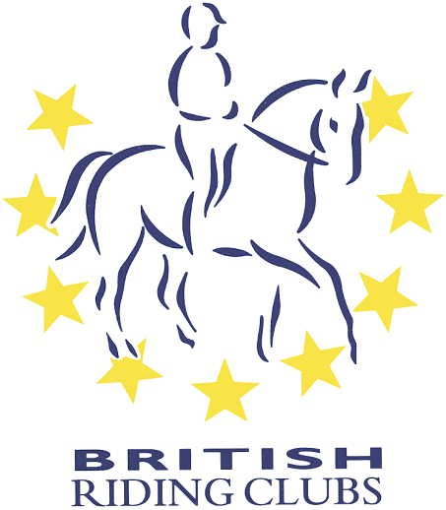
British Riding Club Area 2.
Training application form for events flatwork
Show jumping and cross country training

Organiser – Lezley Aldrich

Venue:…………………………………………………………………..

Date of Training:…………………………………………………………………

Venue:……………………………………………………………………………..

Name:………………………………………………………………………………………………

Member of …………………………………………………………riding club.

Email Address:…………………………………………………………………………………………

Mobile Telephone Number:………………………………………………………………………..

Emergency contact name and address:……………………………………………………………….

Membership Number:……………………………………………………………………………..

Please return to nafftaff@outlook.com
Payment must be made when booking, any refunds will be subjected to a deduction of £1 per horse booking fee
Payment details are on website. www.britishridingridingclubsarea2.com

