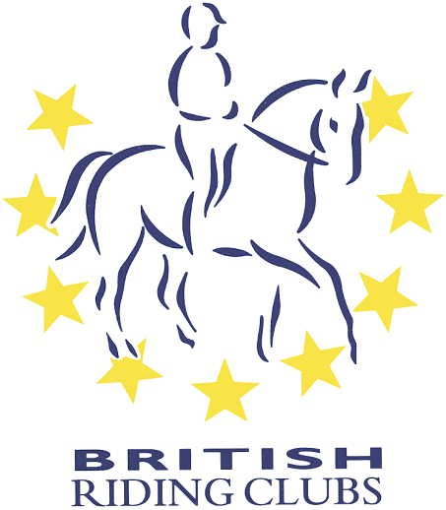
British Riding Club
Area 2.

Jennie Dodd Award.
2025

Jennie Dodd was one of the original members of Newcastle Riding Club, who unfortunately died relatively early in her life. She was devoted to horses and gave a great deal of her time to the club and also Area.
So the area recognises that there are a great deal of people who help at events, meetings etc who never get the recognition they deserve so hence the award which is given for one year is presented.
The award will be presented to the recipient at the Area Liaison meeting on Monday 10th March 2025 at South Causey Hotel. 7.30.p.m. The nominations to be sent to Hilary McKenna by 20th February 2025 by email.
Please give some reason why you wish to nominate the person below. Thank you.

Name of person:…………………………………………………………………………….
Club:………………………………………………………………………………..
Description:

Signature of official of club: ……………………………………………………………….
Position:………………………………………………………………………..

Name of person to contact:………………………………………………………..
Date:………………………………………………………..

