
British Riding Clubs – Area 2.
Training

Some information when sorting out training venues, instructors.

- Choose the venue.
- Look at accessibility
- Look at the facilities, see if they are up to BRC standards
- Do a Risk Assessment, this should include, what kind of training it will be used for. In the RA ensure that safety of instructor and riders.
- Are any moving vehicles in the immediate area.
- Telephone numbers – Vet, Hospital, owner of establishment.
- Instructor to be fully insured – documents seen to prove this.
- Person in overall charge of the training and set up to remain on premises all the time.
- List of attenders and contact numbers in case of emergency.
- Show Jumping lessons – person apart from instructor to be on the ground.
- If any incident happens, immediately after dealing with this, write down in order what has happened and how it was dealt with. Form at end to fill in.
- If the person or horse has to be treated, where the treatment is to be done, and the owner of the horse to be noted.
- Where the horse can be stabled, boxed, if rider is injured and not capable of taking care of the horse.

BRC ACCIDENT / INCIDENT / FALL REPORT FORM
Rider and Horse Information
Competitor number: | Rider name: | Please Circle: MALE / FEMALE / OTHER
Competitor number: | Horses name: | Please Circle: MALE / FEMALE / OTHER
Competitor number: | Horses name: | Please Circle:  JUNIOR / SENIOR
Competitor number: | Club: | Please Circle:  JUNIOR / SENIOR
What Happened
Date of accident: | Time of accident:
Event:


Location of Incident on Site
Accident disciplines: |  | Training | Dressage |  | Show Jumping | Warm Up | Event - Other
Who attended: |  |  |  |  |  | First Aider
Description of accident:
Accident type: | Fall at fence: |  |  | Fall on the flat – not fence related: |  |  | Other:
Accident type: | 1. Rider fall |  |  | 3. Fall on the flat rider only |  |  | 5. Trapped horse
Accident type: | 2. Horse and rider both fell* |  |  | 4. Fall on the flat horse & rider* |  |  | 6. No fall
*A Horse is considered to have fallen when, at the same time, both its shoulder and quarters have touched either the ground or the obstacle and the ground.
•

•
•
Did the fall involve a fence? (“Y”, “N”) | Number: | Element :  (a, b, c etc.) | Route:  ( “D” direct, “O” option) | Did frangible fence fall? (“Y”, “N”, “N/A”)

Ground Conditions: | Deep | Heavy |  | Slippery | Soft |  | Good |  | Firm | Hard |  | Surface
Weather: | Fine |  | Raining |  |  | Snowing |  | Windy |  |  | Indoor

 | YES | NO | Comments
Did horse fall on or tread on rider?
Did the horse slip?
Was air jacket worn?
Did air jacket activate?
Was a body protector worn?

BRC ACCIDENT / INCIDENT / FALL REPORT FORM
Rider name:

Falls at fences (only complete if fall was at a fence)
 |  | YES | NO |  |  | YES | NO
Did horse refuse? |  |  |  | Did horse break the fence?
Did horse hit fence on the way up? |  |  |  | Did horse tip portable fence over?
Did horse hit fence on the way down? |  |  |  | Did horse have a rotational fall*?
Did the rider hit the fence? |  |  |  | Did horse have a torsional fall**?
*Rotational fall: horse is considered to have had a rotational fall when it somersaults as a result of hitting a fence. To clarify this further, the horse's hindquarters end up significantly higher than its front end and it will land on the landing side of the fence.
**Torsional fall: horse is considered to have had a torsional fall when he twists and lands on his shoulder or side.
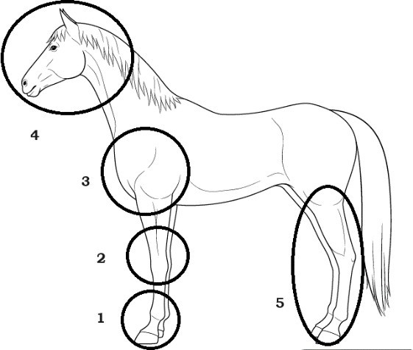
To be completed if accident involved a collision between a Horse and a fence.
Please circle the number indicating the initial point of impact between the Horse and the fence.

1 - 2 - 3 - 4 or 5
Severity of Horse Injury: | No Injury | Slight  Lame, Laceration |  | Serious  Open wound, non-weight baring, heavy bleeding | Fatal | Unknown
Severity of Human Injury: | No Injury | Slight  Sprain, Cut, Bruise |  | Concussed | Serious  Hospital treatment | Fatal

What went wrong | YES | NO
Situation misjudged by rider
Horse out of control
Horse going too fast
Horse going too slow
Horse jumping into bright / sunlight or reflection
Horse jumping into shadow
Horse fatigued
Horse impaired by health/injury
Any additional comments:

Information on person completing the form:
Name: | Role:
Club: | Email/Telephone:

